24/01/2025, 11:28 Linear_Regression.ipynb - Colab
1
import numpy as np
2
import matplotlib.pyplot as plt
3
from sklearn.linear_model import LinearRegression
4
from sklearn.metrics import mean_squared_error, r2_score # to evaulate the fit
1
# Step 1: Generate synthetic data (y = 2x + 3 + noise)
2
np.random.seed(42)
3
X = np.random.rand(100, 1) * 10
4
y = 2 * X + 3 + np.random.randn(100, 1) * 2 # Add some noise
1
# Step 2: Visualize the data
2
plt.scatter(X, y, color='blue', label='Data points')
3
plt.title("Generated Data")
4
plt.xlabel("X values")
5
plt.ylabel("y values")
6
plt.legend()
7
plt.show()
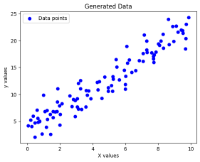
1
# Step 3: Train a Linear Regression model
2
model = LinearRegression()
3
model.fit(X, y) # Fits the model on the data
4
5
# Step 4: Predict using the model
6
y_pred = model.predict(X)
7
8
# Step 5: Evaluate the model
9
mse = mean_squared_error(y, y_pred)
10 11 12
r2 = r2_score(y, y_pred)
print(f"Model Coefficient (slope): {model.coef_[0][0]:.2f}")
13
print(f"Model Intercept: {model.intercept_[0]:.2f}")
14
print(f"Mean Squared Error: {mse:.2f}")
15
print(f"R-squared (R²) Score: {r2:.2f}")
16
17
# Step 6: Visualize the regression line
18
plt.scatter(X, y, color='blue', label='Actual data')
19
plt.plot(X, y_pred, color='red', linewidth=2, label='Regression line')
20
plt.title("Linear Regression Fit")
21
plt.xlabel("X values")
22
plt.ylabel("y values")
23
plt.legend()
24
plt.show()
https://colab.research.google.com/drive/1s1-PfGbjzRyRmzU65CvvhtATaq9a9WjV#scrollTo=CO_3bENx2hI7&printMode=true 1/4
24/01/2025, 11:28 Linear_Regression.ipynb - Colab
Model Coefficient (slope): 1.91
Model Intercept: 3.43
Mean Squared Error: 3.23
R-squared (R²) Score: 0.91
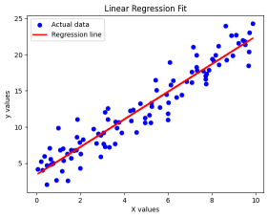
1 # REAL WORLD EXAMPLE
1
import numpy as np
2
import matplotlib.pyplot as plt
3
from sklearn.linear_model import LinearRegression
4
from sklearn.metrics import mean_squared_error, r2_score
5
from mpl_toolkits.mplot3d import Axes3D
1
# Step 1: Generate synthetic real estate data
2
np.random.seed(42) # Ensure reproducibility
3
4
# Generate house sizes (1000 - 4000 sq. ft.)
5
house_sizes = np.random.randint(1000, 4000, size=(100, 1))
6
7
# Generate number of bedrooms (1 - 5)
8
num_bedrooms = np.random.randint(1, 6, size=(100, 1))
9
10
# Formula: price = (150 * size) + (20000 * bedrooms) + base_price + noise
11
# We should get the coefficients close to this value
12
base_price = 50000
13
price_per_sqft = 150
14
price_per_bedroom = 20000
15
16
house_prices = (
17
price_per_sqft * house_sizes +
18
price_per_bedroom * num_bedrooms +
19
base_price +
20
np.random.randint(-20000, 20000, size=(100, 1))
21
)
1
# Combine the features into a single dataset
2
X = np.hstack((house_sizes, num_bedrooms)) # Combine both features into a single matrix
3
y = house_prices
4
5
# Step 2: Visualize data in 3D
6
fig = plt.figure(figsize=(10, 6))
7
ax = fig.add_subplot(111, projection='3d')
8
ax.scatter(house_sizes, num_bedrooms, house_prices, color='blue', label='Data points')
9
ax.set_xlabel("House Size (sq. ft.)")
10
ax.set_ylabel("Number of Bedrooms")
11
ax.set_zlabel("House Price (USD)")
12
plt.title("House Prices vs Size and Bedrooms")
13
plt.legend()
14
plt.show()
https://colab.research.google.com/drive/1s1-PfGbjzRyRmzU65CvvhtATaq9a9WjV#scrollTo=CO_3bENx2hI7&printMode=true 2/4
24/01/2025, 11:28 Linear_Regression.ipynb - Colab 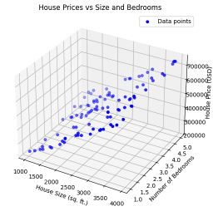
1
# Step 3: Train a Linear Regression model
2
model = LinearRegression()
3
model.fit(X, y)
4
5
# Step 4: Make predictions
6
predicted_prices = model.predict(X)
7
8
# Step 5: Evaluate the model
9
mse = mean_squared_error(y, predicted_prices)
10 11 12
r2 = r2_score(y, predicted_prices)
print(f"Model Coefficients (Price per Sq.Ft, Price per Bedroom): {model.coef_[0][0]:.2f}, {model.coef_[0][1]:.2f}") 13
print(f"Model Intercept (Base Price): ${model.intercept_[0]:.2f}")
14
print(f"Mean Squared Error: {mse:.2f}")
15
print(f"R-squared (R²) Score: {r2:.2f}")
16
17
# Step 6: Visualize the fit
18
19
fig = plt.figure(figsize=(10, 6))
20
ax = fig.add_subplot(111, projection='3d')
21
22
# Scatter plot of actual data points
23
ax.scatter(house_sizes, num_bedrooms, house_prices, color='blue', label="Actual prices")
24
25
# Generate grid for visualization
26
house_size_range = np.linspace(min(house_sizes), max(house_sizes), 20)
27
num_bedroom_range = np.linspace(min(num_bedrooms), max(num_bedrooms), 20)
28
house_size_grid, num_bedroom_grid = np.meshgrid(house_size_range, num_bedroom_range)
29
30
# Predict prices based on the grid
31
price_grid = (model.coef_[0][0] * house_size_grid +
32
model.coef_[0][1] * num_bedroom_grid +
33
model.intercept_)
34
35
# Plot the regression plane
36
ax.plot_surface(house_size_grid, num_bedroom_grid, price_grid, alpha=0.3, color='red')
37
38
# Set labels and title
39
ax.set_xlabel("House Size (sq. ft.)")
40
ax.set_ylabel("Number of Bedrooms")
41
ax.set_zlabel("House Price (USD)")
42
ax.set_title("Linear Regression Fit for House Prices")
43
ax.legend()
44
45
plt.show()
46
47
https://colab.research.google.com/drive/1s1-PfGbjzRyRmzU65CvvhtATaq9a9WjV#scrollTo=CO_3bENx2hI7&printMode=true 3/4
24/01/2025, 11:28 Linear_Regression.ipynb - Colab
Model Coefficients (Price per Sq.Ft, Price per Bedroom): 147.99, 20262.80 Model Intercept (Base Price): $52555.62
Mean Squared Error: 131017071.15
R-squared (R²) Score: 0.99
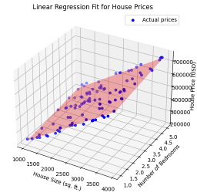
1
# Reasoning
2
3
# 1) Learned weights are close to the original price per sq. ft., price per bedroom 4
# 2) There is small variance because of limited samples and random noise added
https://colab.research.google.com/drive/1s1-PfGbjzRyRmzU65CvvhtATaq9a9WjV#scrollTo=CO_3bENx2hI7&printMode=true 4/4

